Провал 1:
Use the provided empty workshop table image @Image1 as the starting frame and the completed epoxy table image @Image2 as the ending frame.
The camera is static and does not move. The scene is a cozy woodworking workshop with tools, lumber shelves, and workbenches. In the foreground there is a large pink epoxy table mold on a workbench, viewed from the near end in strong one-point perspective extending into the workshop.
A woman woodworker @Woodworking Woman enters the frame and begins assembling the table.
Sequence of actions:
1. The woman @Woodworking Woman carefully places two large live-edge walnut slabs into the mold, positioning them along the left and right edges to form a river channel in the middle.
2. In a timelapse effect, she @Woodworking Woman places whiskey bottles one by one into the center channel between the slabs. The bottles accumulate until the middle section is filled.
3. In another timelapse, she @Woodworking Woman scatters amber-colored gemstones between the bottles, filling the remaining gaps.The bottles and gemstones gradually fill the river channel until the table composition matches the final reference image @Image2 exactly.
Lighting remains warm workshop lighting from the windows. Sawdust and tools remain unchanged. Preserve the exact camera angle and geometry of the reference image throughout the entire video.

Провал 2:
Use the provided empty workshop table image @Image1 as the starting frame and the completed epoxy table image @Image2 as the ending frame.
The camera is static and does not move. The scene is a cozy woodworking workshop with tools, lumber shelves, and workbenches. In the foreground there is a large pink epoxy table mold on a workbench, viewed from the near end in strong one-point perspective extending into the workshop.
A woman woodworker @Woodworking Woman enters the frame and begins assembling the table.
Sequence of actions:
1. The woman carefully places two large live-edge walnut slabs into the mold, positioning them along the left and right edges to form a river channel in the middle.
2. In a timelapse effect, she places whiskey bottles one by one into the center channel between the slabs. The bottles accumulate until the middle section is filled.
3. In another timelapse, she scatters amber-colored gemstones between the bottles, filling the remaining gaps.The bottles and gemstones gradually fill the river channel until the table composition matches the final reference image exactly.
A single female @Woodworking Woman from the provided reference element is the only person in the scene. No extra people.
Realistic diegetic workshop sounds: wood slab thuds on the mold, glass bottle clinks during placement, small gemstone drops and soft scattering sounds, subtle indoor woodworking ambience.

Успех 1 (Трябва да се ползва Custom Multi Shot в Kling Omni):
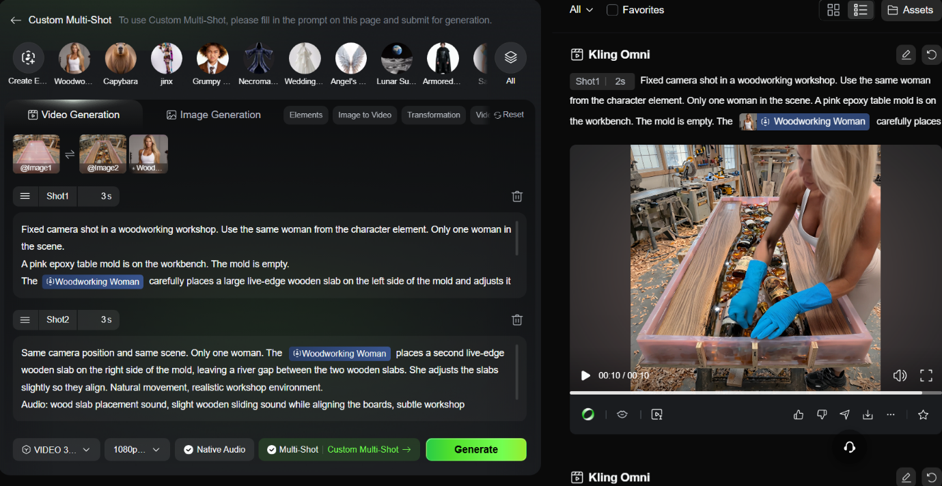

Shot 1:
Fixed camera shot in a woodworking workshop. Use the same woman from the character element. Only one woman in the scene.
A pink epoxy table mold is on the workbench. The mold is empty.
@The Woodworking Woman carefully places a large live-edge wooden slab on the left side of the mold and adjusts it slightly.
Realistic movement. Natural workshop lighting.
Audio: clear heavy wood placement sound as the slab touches the mold, light wood friction sound while adjusting, subtle workshop ambience.
Shot 2:
Same camera position and same scene. Only one woman. @The Woodworking Woman places a second live-edge wooden slab on the right side of the mold, leaving a river gap between the two wooden slabs. She adjusts the slabs slightly so they align. Natural movement, realistic workshop environment.
Audio: wood slab placement sound, slight wooden sliding sound while aligning the boards, subtle workshop background ambience.
Shot 3:
Same fixed camera and same woman.The wooden slabs are already placed. The @Woodworking Woman carefully places whiskey bottles into the river channel between the wood slabs one by one, arranging them neatly. Slow natural movements.
Audio: distinct glass bottle clink sounds as each bottle is placed, light glass tapping sounds, subtle workshop ambience.
Shot 4:
Same fixed camera and same woman.The bottles are already placed between the wooden slabs. @The Woodworking Woman carefully places decorative gemstones into the remaining spaces between the bottles one by one. Slow precise hand movements.
Audio: small stone dropping sounds, light gemstone tapping sounds against glass bottles, subtle workshop ambience.

Успех 2:
Same fixed camera and same woman. Exactly one woman in the scene.
The scene starts from the provided first frame where several whiskey bottles are already placed in the river channel between the wooden slabs.
The @Woodworking Woman quickly cоntinues placing the remaining whiskey bottles and decorative gemstones into the channel. The process appears as a smooth construction timelapse while she moves naturally around the table, working from different sides.
Objects appear as if they are being placed by the woman and gradually fill the channel until the arrangement matches the provided last frame reference.
Audio: rapid glass bottle clinks and small stone placement sounds during the timelapse, subtle workshop ambience.
Take @Image1 as the start frame, Take @Image2 as the end frame

